Kingian Nonviolence Conflict Reconciliation:
Two Day Orentation

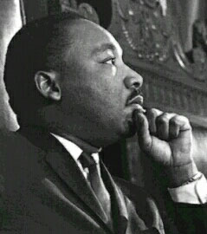

Clarkston Community Center

3701 College Avenue

Clarkston, GA 30021
404-508-1050

Friday July 29th 4pm-9pm
Saturday July 30th 8:30am-3:30pm

Come learn Dr. Martin Luther King Jr.’s methodology of nonviolent conflict reconciliation. The Clarkston Community Center invites distinguished community, law enforcement, and government leaders to receive the Introductory Two-Day Training, in hopes that participants of the training will then teach the Kingian Nonviolence principles and strategies to Clarkston Community youth and residents.

The training will be led by civil rights activist, Distinguished Scholar-in-Residence at Emory's Candler School of Theology, Dr. Bernard Lafayette Jr. and Senior Nonviolence Trainer Charles Alphin Sr.
Dr. Lafayette established Lafayette and Associates to teach the foundations of nonviolence. In addition to his work with Dr. Martin Luther King Jr. during the civil rights movement, Dr. Lafayette has served as Director of Peace and Justice in Latin America; Chairperson of the Consortium on Peace Research, Education and Development; Director of the PUSH Excel Institute; and minister of the Westminster Presbyterian Church in Tuskegee, Alabama.

There is no cost for the training and food will be provided. Participants are required to attend both days of the training

RSVP info@clarkstoncommunitycenter.org
Questions? Maddox.Camille@yahoo.com

